Logical Thinkg and Writing Program

Presentation close up
Highlights
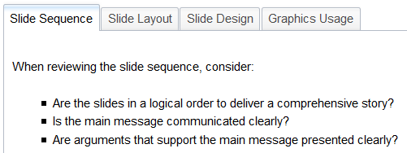
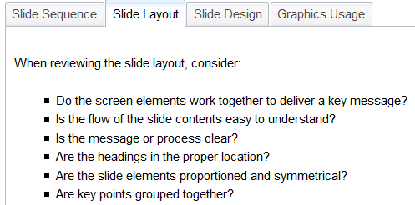
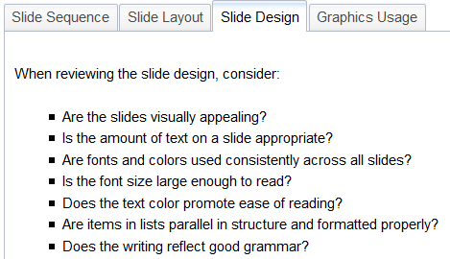
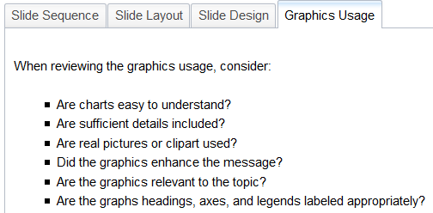
What went wrong?
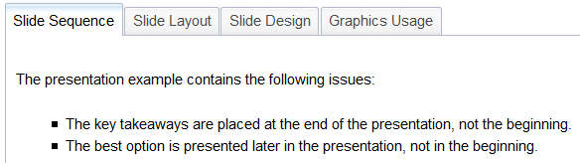
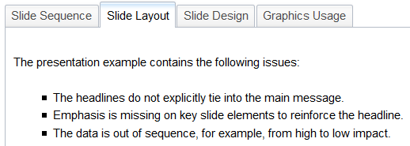
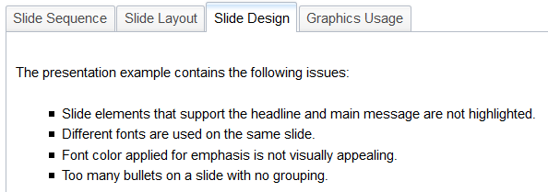
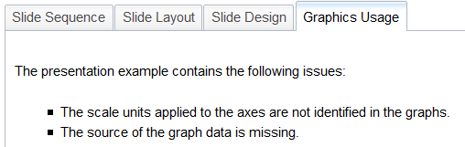

Getting started
An effective presentation is easy to understand:
- Presentations are structured using Pyramid standards of writing, which apply top down and inductive logic.
- The main idea should be expressed on top in full phrases and subsequent ideas should be grouped and sequenced logically below.
- Thoughtful graphic design enhances and supports the communication process.
- A concise style focuses the client on the key message and its supporting points.
Effective communication relies on the consultant's ability to think, write, and present key messages clearly. This enables the client to grasp the value of the consultant's ideas.
When creating presentations, it is important that:
- Every slide element contributes to the main message.
- Slides progress in a logical sequence to deliver a key message.
- Each slide is able to stand alone.
- Information included on a particular slide is relevant to the slide title.
- Slide formatting emphasizes the key message and is consistent throughout the presentation.

Presentation Basics

Pyramid structure for presentations
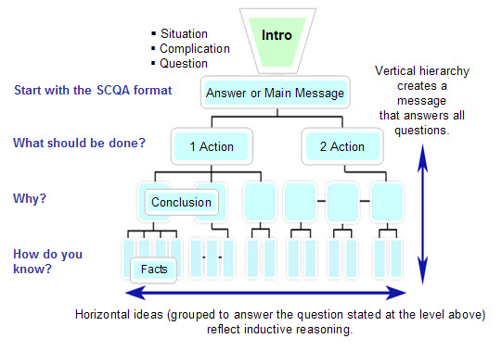

Key elements
There are four key elements of an effective presentation: purpose, title, storyline, and logic.
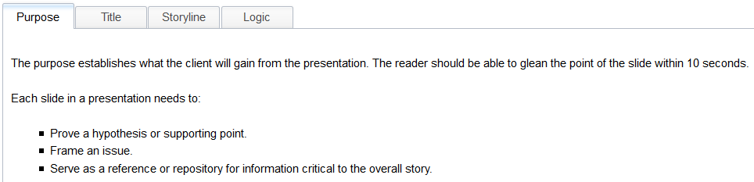
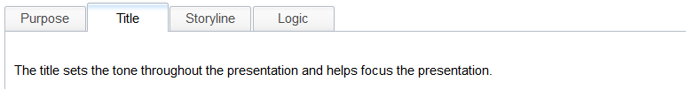
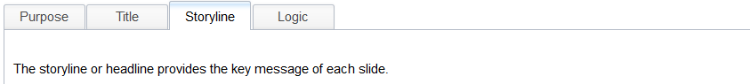
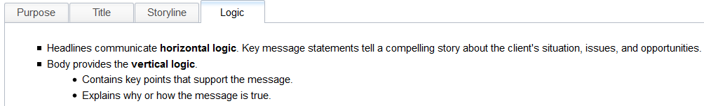

Key Attributes on a slide
All of the slide content should be necessary and sufficient to answer the "How do you know?" question. Be sure that each slide is CLEAR: Comprehensive, Lively, Elegant, Accurate, and Relevant.

Basic content slide architecture
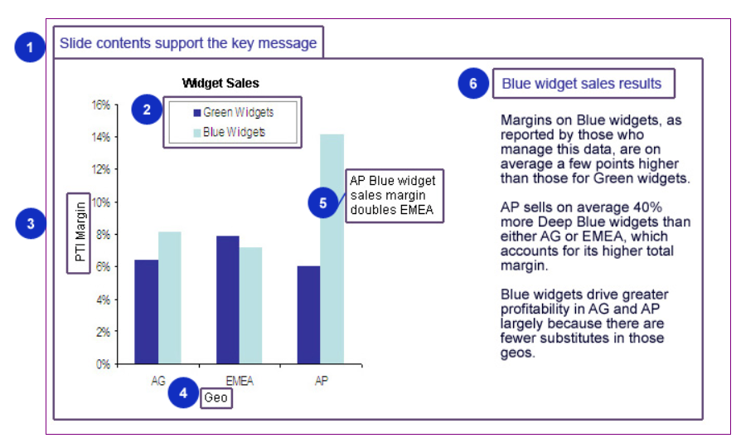

Content slide standards
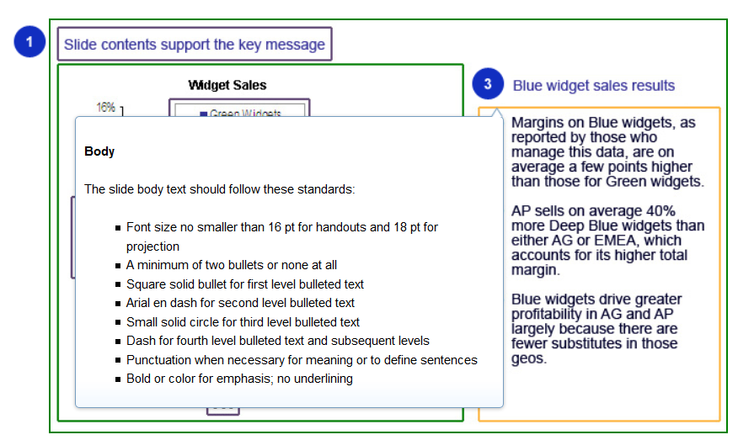

Charting Standards applied
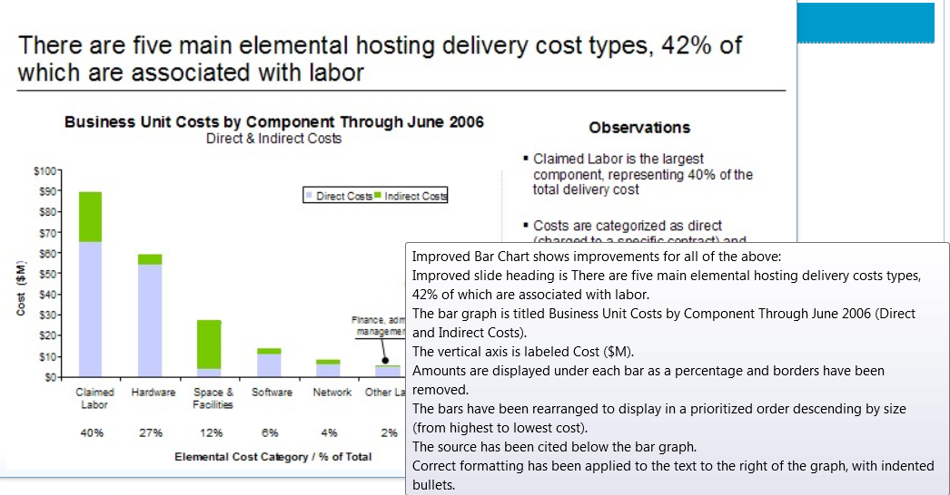

Structured Presentations
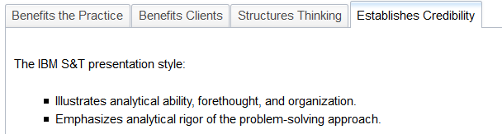

Writing format comparison: Deductive versus Inductive
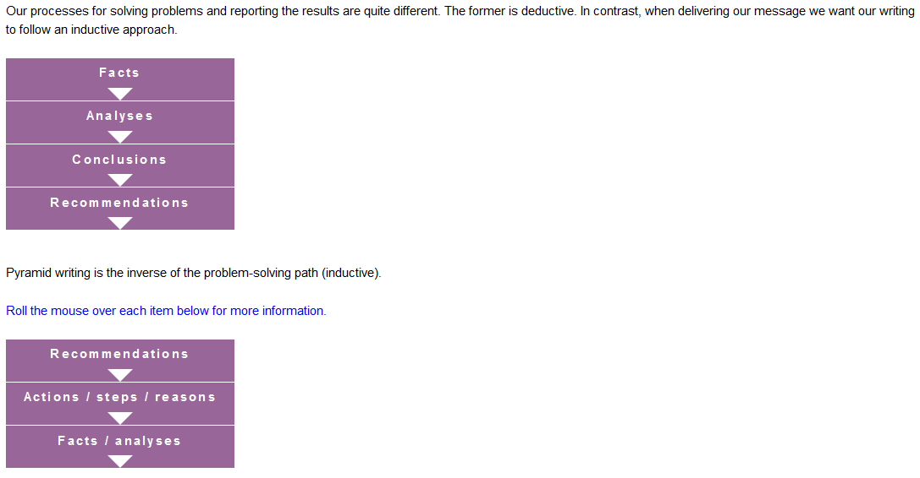

Applying pyramid writing to presentations
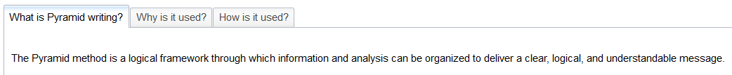
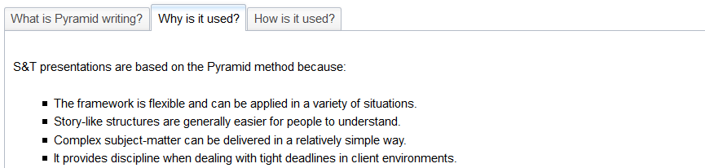
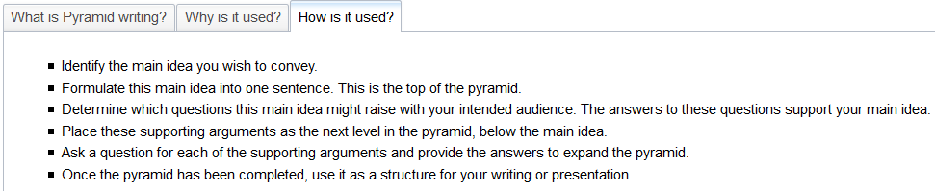
Below are additional Pyramid writing guidelines.
- The main idea and supporting points are organized using top down (inductive) logic.
- Each page starts with a full sentence summarizing the idea.
- An idea at any level summarizes the ideas grouped below.
- The ideas in each group are of the same kind.
- Each idea group has an apparent ordering logic.
- Each group contains no more than five (plus or minus two) ideas.

Creating a compelling message
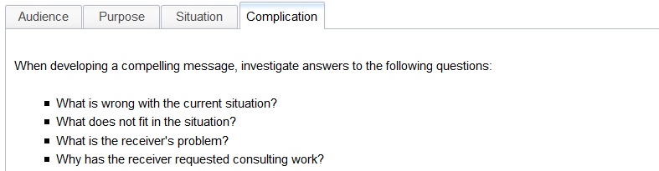

Writing in pyramid structure: SCQA
Pyramid writing follows the Situation, Complication, Question, and Answer format.

Forming the governing thought
The governing thought answers the key question. This main message must be TOPS.
Targeted to the audience
Over-arching
Powerful
Supportable
Below are examples of governing thoughts. The second thought is TOPS.
1. The company can improve its processes for dealing with customers.
2. The major organizational problem you face is your inability to delegate authority.

Governing thought: logical arguments
Inductive Argument
The premises of an inductive argument indicates some degree of support for the conclusion. The premises suggests truth, but does not ensure it. In the inductive approach, one starts with the recommendation which is then followed by supporting statements. Each of the supporting statements supports the recommendation. Because each supporting statement is not dependent on other statements, if one statement is not agreed, the recommendations are still supported by the other statements.
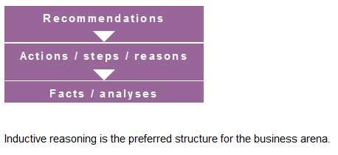

Applying the MECE principle
It is critical that the supporting statements for your argument be mutually exclusive and collectively exhaustive (MECE) to demonstrate clear thinking.
Mutually exclusive: Is each point used only once and in the best place?
Collectively exhaustive: Do you have all the points you need to support or defend the summary idea?

Keys to pyramid writing
The Pyramid writing approach focuses on the following key points:
- Check the foundations:
  - Are you clear who your audience is?
  - Are you certain about the goal of your message?
  - Are you certain about the situation?
  - Are you clear what the problem is?
- Check the pyramid outline:
  - Do the situation, problem and main idea fit together properly?
  - Is your pyramid a question-and-answer dialogue?
  - Are the pyramid building blocks formulated as proper sentences?
  - Is the main idea a one-sentence summary of your message?
- Check the construction:
  - Is the vertical question-and-answer dialogue complete?
  - Are elements supported by at least two and no more than five supporting elements?
  - Have all supporting elements been ordered as a group or valid chain?
- Check the relationships:
  - Are the supporting elements Mutually Exclusive and Collectively Exhaustive (MECE)?
  - Do the supporting elements under one higher-level element have the same level of abstraction?
  - Do the supporting elements under one higher-level element answer the same question?
  - Are the supporting elements in a logical sequence?

Narrative communications

Inductive report structure

