VDP: Differentiating to Win

Overview

Proposal process
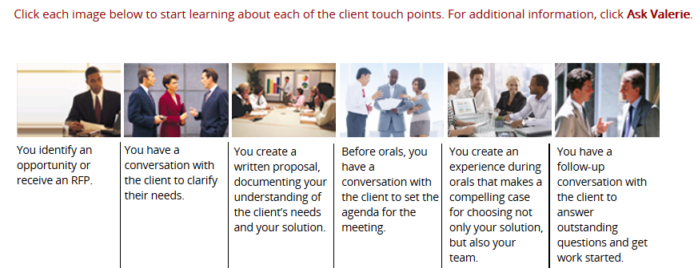

New Thinking
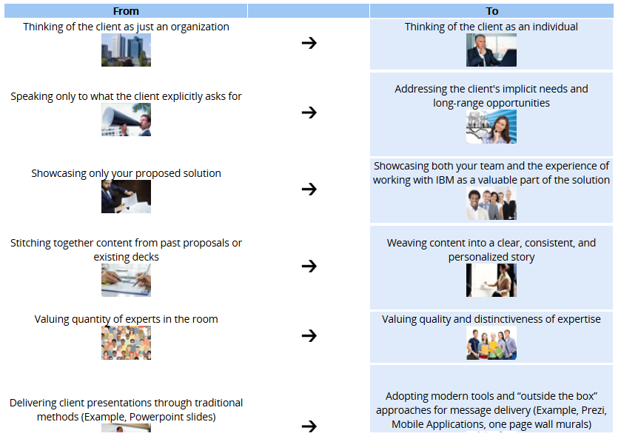

The VPD Method
The VDP method helps you successfully pitch new deals by focusing on five key steps:
01 Getting grounded
02 Writing the story
03 Preparing for orals
04 Delivering the experience
05 Following through
You will begin by:
- Understanding your client as an individual, adopting their point of view and seeing where they are, and then determining what matters most to them.
- Next, you will craft the story of your written proposal, and then refocus it for the orals experience.
- You will plan on how to present the story in orals, including the role of each team member and the right supporting visuals.
- Finally, you will learn how to best engage each client during orals and beyond.
For each step, you will learn the core concepts and best practices. You will prepare a set of exercises and tools to guide your work. You will write the proposal and design the orals experience, including the materials needed in the room, and rehearse your delivery prior to the meeting.

Module: 01 Getting grounded
